Lab # 11

System Programming



Teacher | Bibi Areej Khan
Student Name | Muhammad Ahmad Khan
Registration No | 23JZBCS0238

Department of CS&IT
University of Engineering and Technology Peshawar
(Jalozai Campus)

Objective
The objectives of this lab are:
- To understand the hierarchical structure of UNIX/Linux file systems
- To learn directory traversal techniques:
  - Depth-First Search (DFS)
  - Breadth-First Search (BFS)
- To implement recursive directory traversal using DFS
- To implement queue-based traversal using BFS
- To develop a simplified version of the find utility called pfind
- To strengthen concepts of:
  - Directories
  - Recursion
  - Queues
  - File handling in Linux

Theory
In UNIX/Linux operating systems, the file system is organized in a hierarchical tree structure.
- The root directory is at the top.
- Each directory may contain:
  - Files
  - Subdirectories
This creates multiple levels similar to a tree data structure.
Directory traversal is the process of visiting all files and directories inside a file system hierarchy. Traversal is widely used in:
- File searching
- Backup utilities
- File indexing
- Antivirus scanning
- System administration tools
There are two major traversal techniques:

Depth-First Search (DFS)
Depth-First Search explores one branch completely before moving to another branch.
DFS is naturally implemented using recursion.

Working of DFS
- Visit current directory
- Process files and subdirectories
- Recursively visit each subdirectory
DFS goes deep into the directory tree before returning back.

Breadth-First Search (BFS)
Breadth-First Search explores directories level by level.
Unlike DFS, BFS uses a queue data structure.

Working of BFS
- Insert root directory into queue
- Remove one directory from queue
- Visit all children
- Insert subdirectories into queue
- Repeat until queue becomes empty
BFS processes all nodes at one level before moving deeper.

File Searching Utility pfind
The Linux find command searches files recursively inside a directory hierarchy.
In this lab, we implement a simplified version called pfind.
The program:
- Takes a filename as input
- Traverses directories recursively
- Prints the full path whenever the file is found

Lab Tasks

Task 01 — Depth-First Traversal (DFS)

Problem Statement
Write a C program that:
- Starts from a root directory
- Uses recursion
- Visits all files and subdirectories
- Displays output in tree format using indentation

DFS Algorithm
depthfirst(root) {

visit(root);

for each node:

if directory:
depthfirst(node);
}

Code
#include <stdio.h>
#include <dirent.h>
#include <sys/stat.h>
#include <string.h>

void dfs(char *path, int level) {

struct dirent *entry;

DIR *dir = opendir(path);

if (!dir)
return;

while ((entry = readdir(dir)) != NULL) {

if (strcmp(entry->d_name, ".") == 0 ||
strcmp(entry->d_name, "..") == 0)
continue;

for (int i = 0; i < level; i++)
printf(" ");

printf("%s\n", entry->d_name);

char newpath[1024];

sprintf(newpath, "%s/%s", path, entry->d_name);

struct stat st;

if (stat(newpath, &st) == 0 &&
S_ISDIR(st.st_mode)) {

dfs(newpath, level + 1);
}
}

closedir(dir);
}

int main() {

dfs(".", 0);

return 0;
}

Compilation Command
gcc task1.c -o task1

Execution Command
./task1

Output

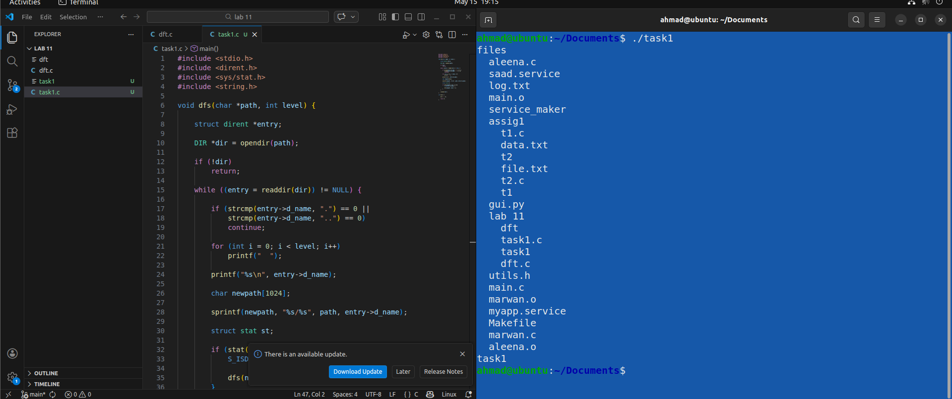Explanation
- opendir() opens a directory.
- readdir() reads directory entries.
- strcmp() ignores:
  - .
  - ..
- stat() checks whether an entry is a directory.
- Recursive function dfs() traverses subdirectories deeply.
- Indentation creates tree-like output.

Task 02 — Breadth-First Traversal (BFS)

Problem Statement
Write a C program that:
- Uses a queue
- Traverses directories level by level
- Prints full path of each node

BFS Algorithm
breadthfirst(root){

enqueue(root);

while(queue not empty){

dequeue(node);

visit(node);

enqueue(children);
}
}

Code
#include <stdio.h>
#include <dirent.h>
#include <string.h>
#include <sys/stat.h>

#define MAX 1000

char queue[MAX][1024];

int front = 0;
int rear = 0;

void enqueue(char *path) {

strcpy(queue[rear++], path);
}

char* dequeue() {

return queue[front++];
}

int isEmpty() {

return front == rear;
}

void bfs(char *root) {

enqueue(root);

while (!isEmpty()) {

char *current = dequeue();

printf("%s\n", current);

DIR *dir = opendir(current);

if (!dir)
continue;

struct dirent *entry;

while ((entry = readdir(dir)) != NULL) {

if (strcmp(entry->d_name, ".") == 0 ||
strcmp(entry->d_name, "..") == 0)
continue;

char path[1024];

sprintf(path, "%s/%s", current, entry->d_name);

struct stat st;

if (stat(path, &st) == 0 &&
S_ISDIR(st.st_mode)) {

enqueue(path);
}
}

closedir(dir);
}
}

int main() {

bfs(".");

return 0;
}

Compilation Command
gcc task2.c -o task2

Execution Command
./task2

Output

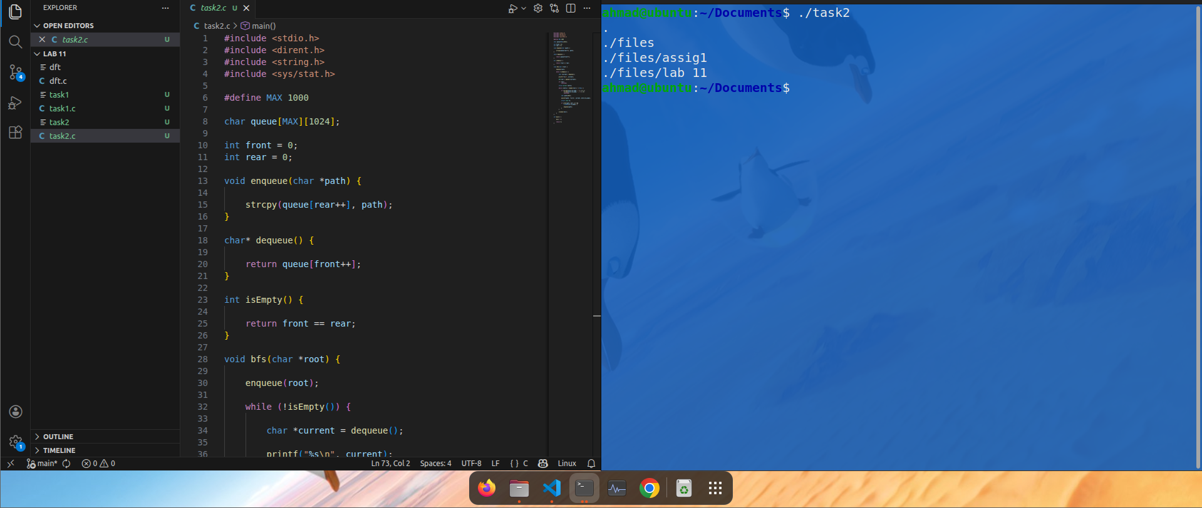Explanation
- BFS uses a queue to store directories.
- enqueue() inserts directories into queue.
- dequeue() removes directories from queue.
- Traversal happens level by level.
- Full paths are displayed during traversal.

Task 03 — File Search Program (pfind)

Problem Statement
Create a program that:
- Takes a filename as input
- Searches directories recursively
- Prints full path when file is found

Code
#include <stdio.h>
#include <dirent.h>
#include <string.h>
#include <sys/stat.h>

void pfind(char *path, char *filename) {

DIR *dir = opendir(path);

if (!dir)
return;
struct dirent *entry;

while ((entry = readdir(dir)) != NULL) {

if (strcmp(entry->d_name, ".") == 0 ||
strcmp(entry->d_name, "..") == 0)
continue;

char fullpath[1024];

sprintf(fullpath, "%s/%s", path, entry->d_name);

if (strcmp(entry->d_name, filename) == 0) {

printf("Found: %s\n", fullpath);
}
struct stat st;

if (stat(fullpath, &st) == 0 &&
S_ISDIR(st.st_mode)) {

pfind(fullpath, filename);
}
}
closedir(dir);
}

int main() {

char filename[100];

printf("Enter file name to search: ");

scanf("%s", filename);

pfind(".", filename);
return 0;
}

Compilation Command
gcc task3.c -o task3

Execution Command
./task3

Output

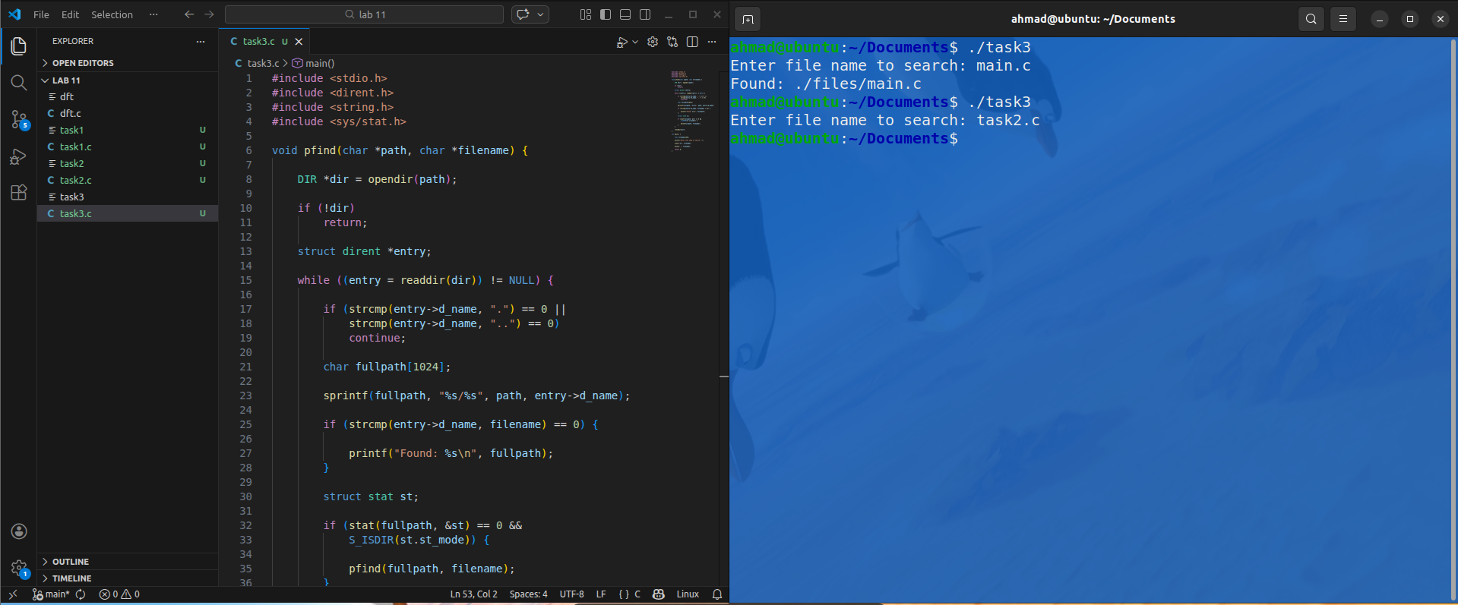Explanation
- User enters a filename.
- Program recursively traverses directories.
- strcmp() checks filename match.
- stat() determines whether entry is a directory.
- If directory is found:
  - pfind() calls itself recursively.
- Full path is printed when file is found.

Important Functions Used
Function | Purpose
opendir() | Opens a directory
readdir() | Reads directory entries
closedir() | Closes directory
stat() | Retrieves file information
strcmp() | Compares strings
sprintf() | Creates formatted paths

Conclusion
In this lab, we studied directory traversal techniques in UNIX/Linux systems using C programming.
We implemented:
- Depth-First Search (DFS)
- Breadth-First Search (BFS)
- A custom file search utility (pfind)
The lab improved understanding of:
- Hierarchical file systems
- Recursive programming
- Queue-based traversal
- File and directory handling in Linux
These concepts are fundamental in system programming and are widely used in file managers, search utilities, backup systems, and operating system tools.

